Six Hats Thinking Reflection
Comments/Feedback
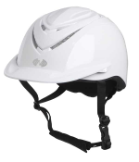
WHITE HAT

Describe the fundraising task in your own words.

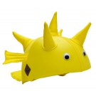
YELLOW HAT

What was good about being part of the project? List many things.

BLACK HAT

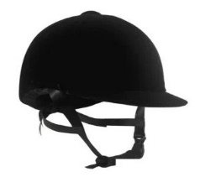
What were some of the problems you encountered during the exercise?
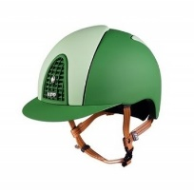
GREEN HAT

Describe some creative ways you overcame these difficulties.

RED HAT

What did you feel about the task? Which aspects
of the task were:
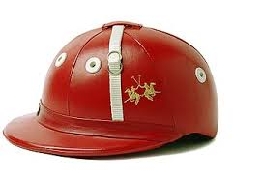
Frustrating? Interesting?
Challenging? Rewarding?
BLUE HAT
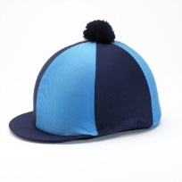
In what ways do you think taking part in a project like this has been a valuable learning experience?

