**FISHBONE: EFFECTS OF RDA PARTICIPATION**

**RIDER –**

**Psychological**

**RIDER - Physical**

**RIDER - Social**

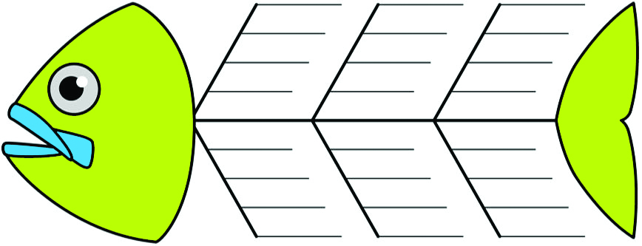

**RIDER –**

**Sporting**

**VOLUNTEERS**

**FAMILIES**